**What is digital analytics?**

People usually purchase goods in stages. In marketing there is this concept of purchase funnel which refers to various stages of customer interaction.

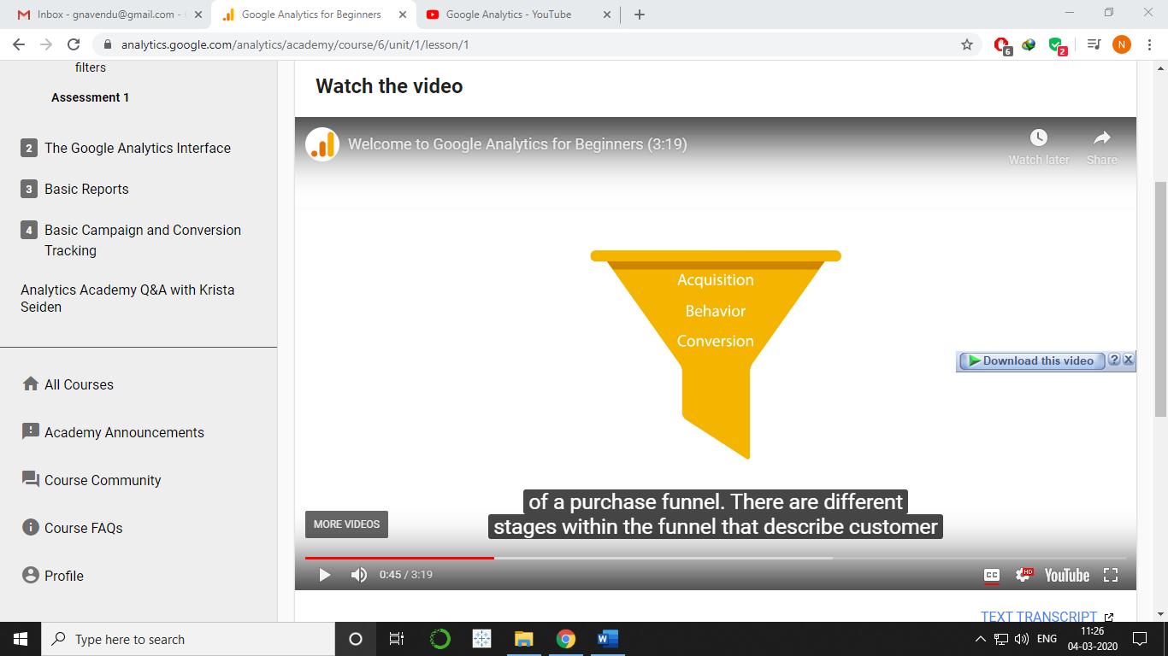

Acquisition: Building awareness and acquire users’ interest.

Behaviour: When users engage with the business.

Conversion: When users become a customer and transacts with the business.

In offline, these parameters are hard to measure but in online world these are measured using digital analytics. We can measure which user behaviour led to purchases and use that data to make informed decisions like how to reach new and existing customers.

We can use digital analytics to better engage with our customers, advertise our products effectively, remove a function or process from our webpage or app that is troubling the users a lot. It helps in understanding user’s behaviour and better market their product and services. Sales team can use this to find out the potential leads.

Google analytics can collect data from a variety of platforms like mobile applications, online point of sale systems, video game consoles, customer relationship management systems or other internet connected platforms. This data is compiled in analytics report and is further used for in depth analysis.